CSE 5306-004 Distributed Systems Project 1

Team 22

Niranjan Kumar Gurram, UTA ID 1002164688

Vinay Datta Chenimineni, UTA ID 1002159126

**Q1:** **Getting familiar with how to container an application using Docker**

Vinay – Java

Building Java Image

Sample application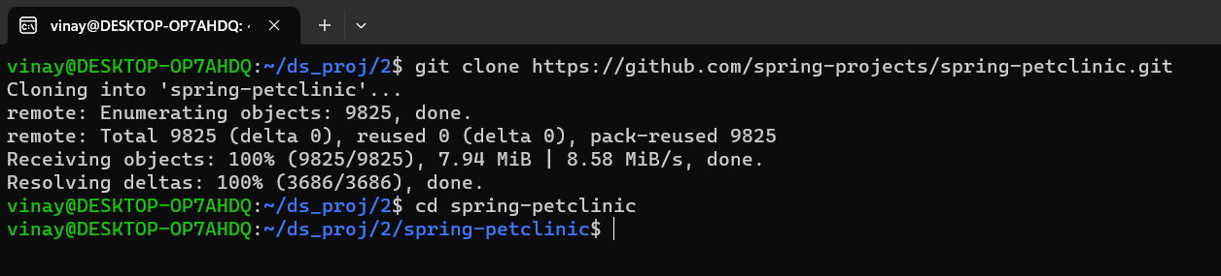

Create a Dockerfile for Java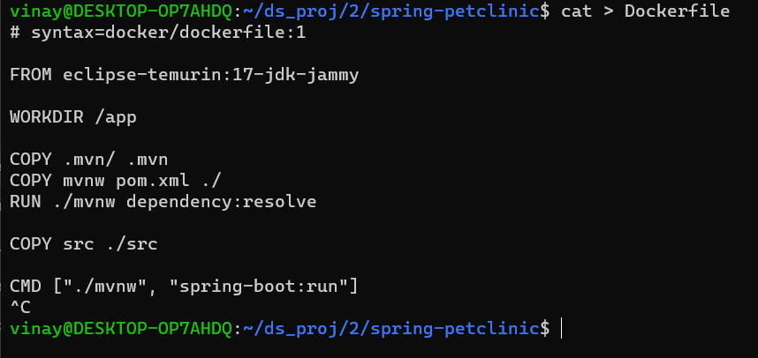

Create a .dockerignore file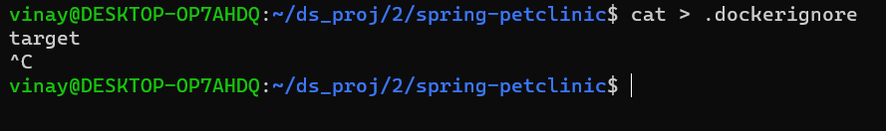

Build an image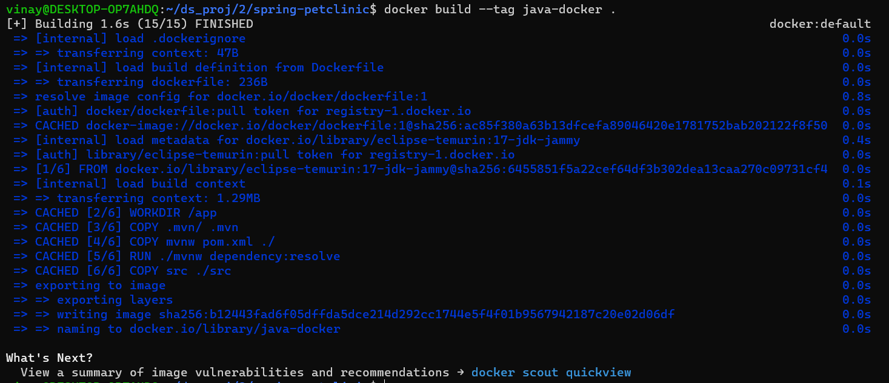

View local images

Tag images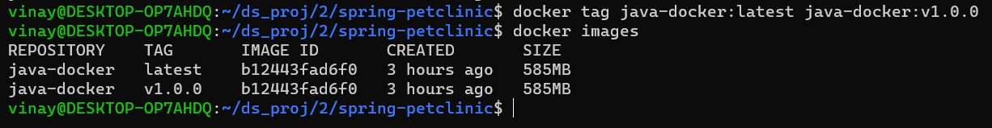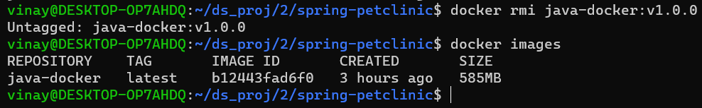

Running Image as a Container

Trying to access application as-is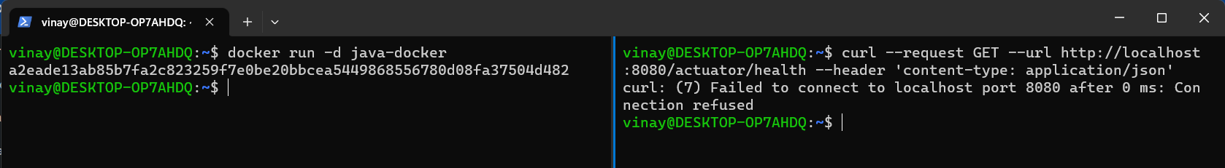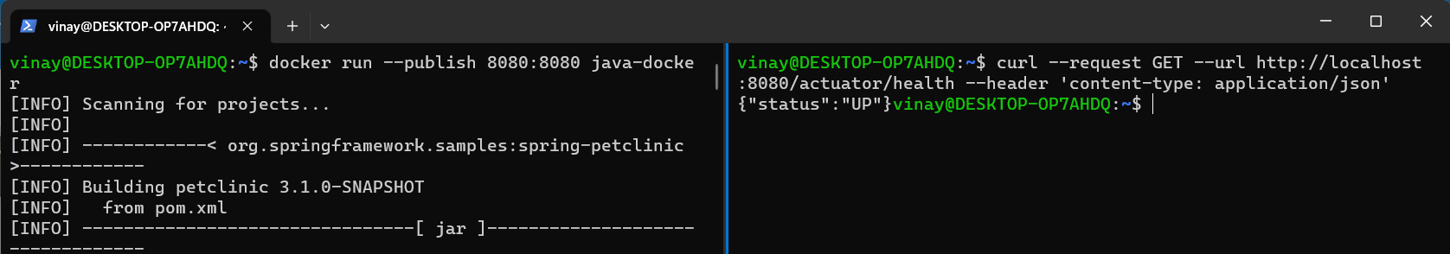

Detached mode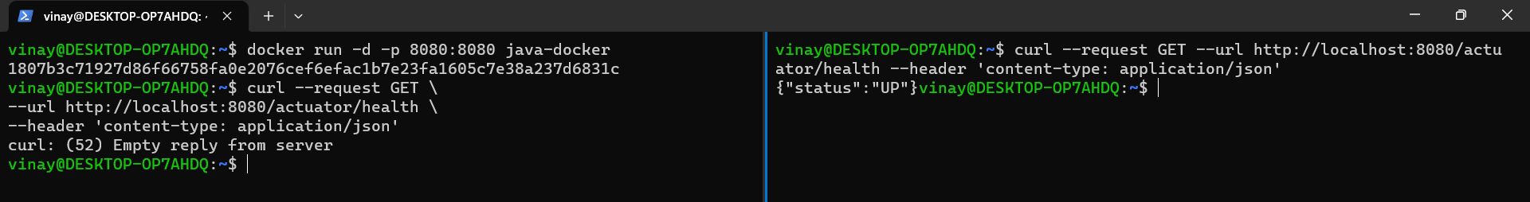

List Containers

Stop, start, and name containers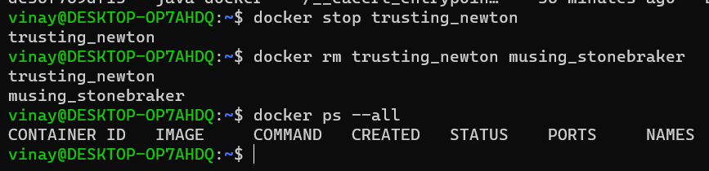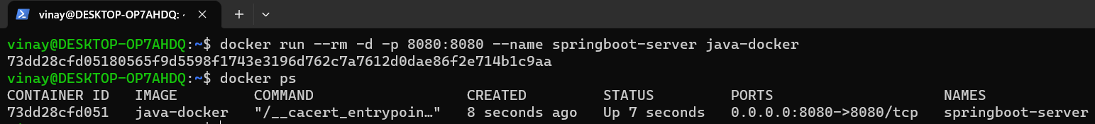

Developing app

Run a database in a container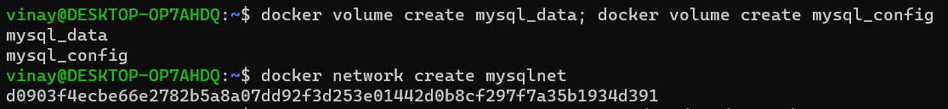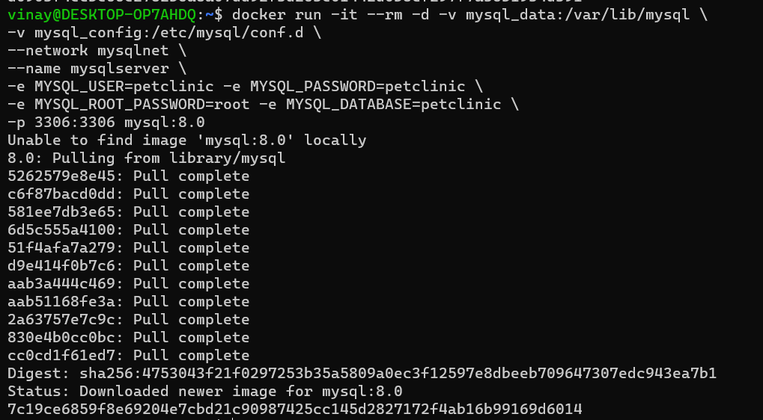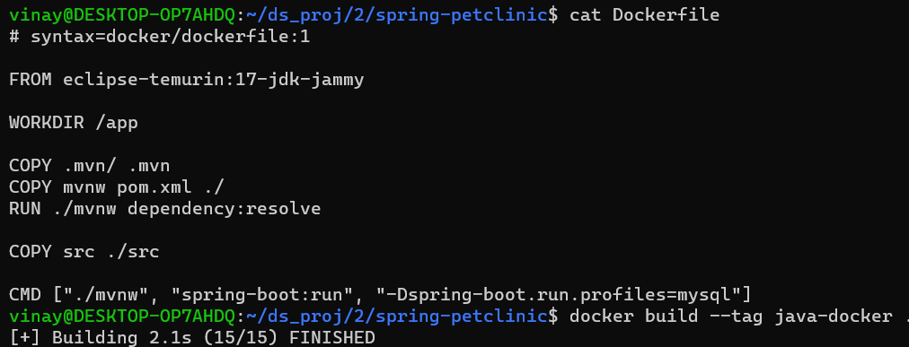

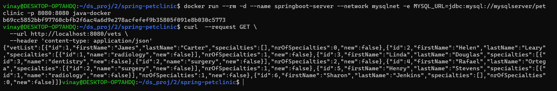

Multi-stage Dockerfile for development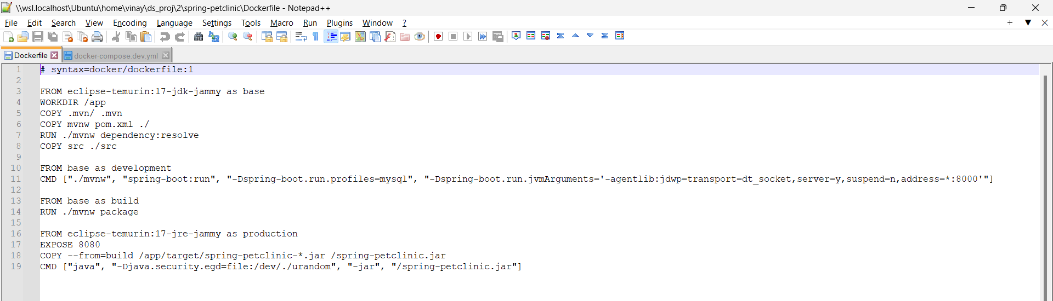

Use compose to develop locally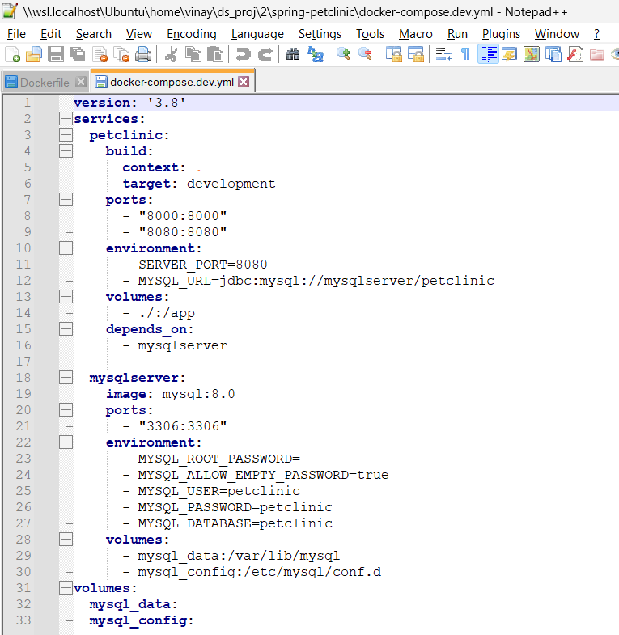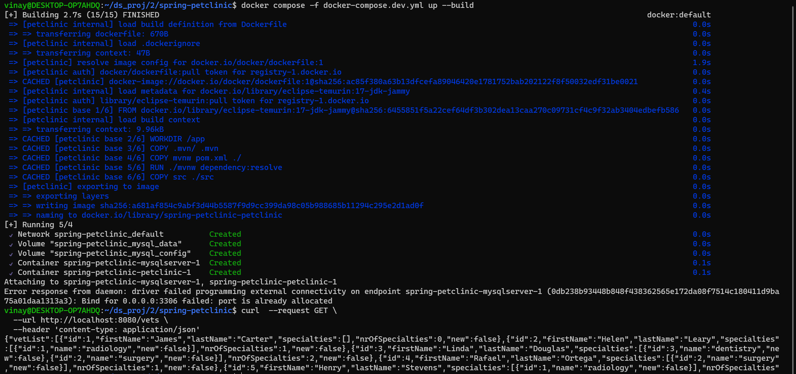

Niranjan – Python

Building Python Image

Sample Application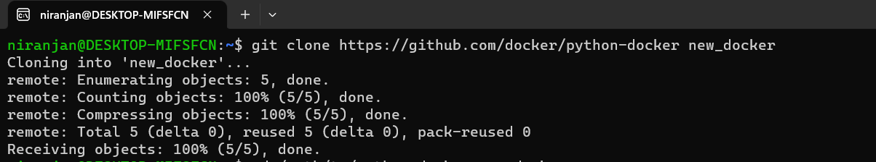

Create a Dockerfile for Python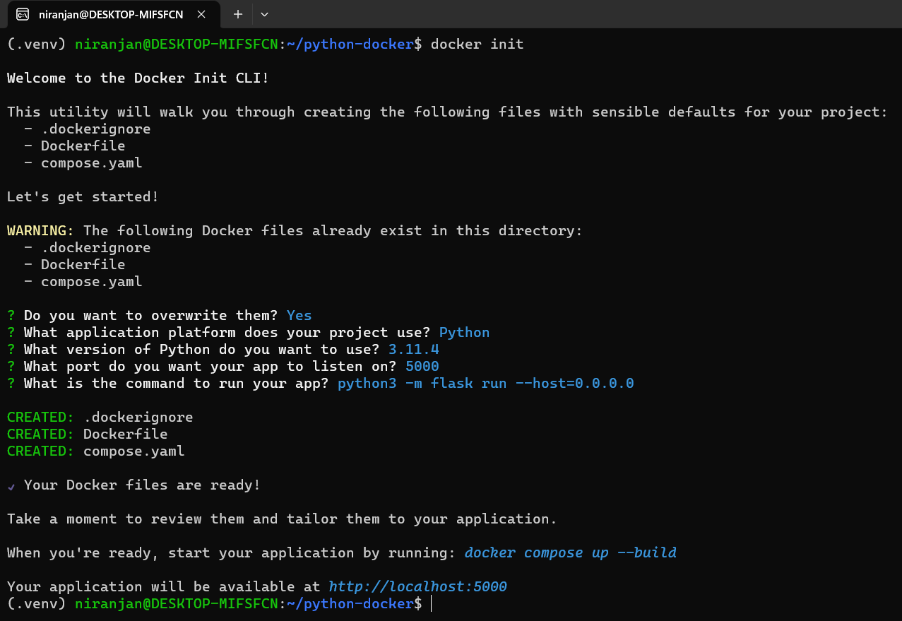

Build an image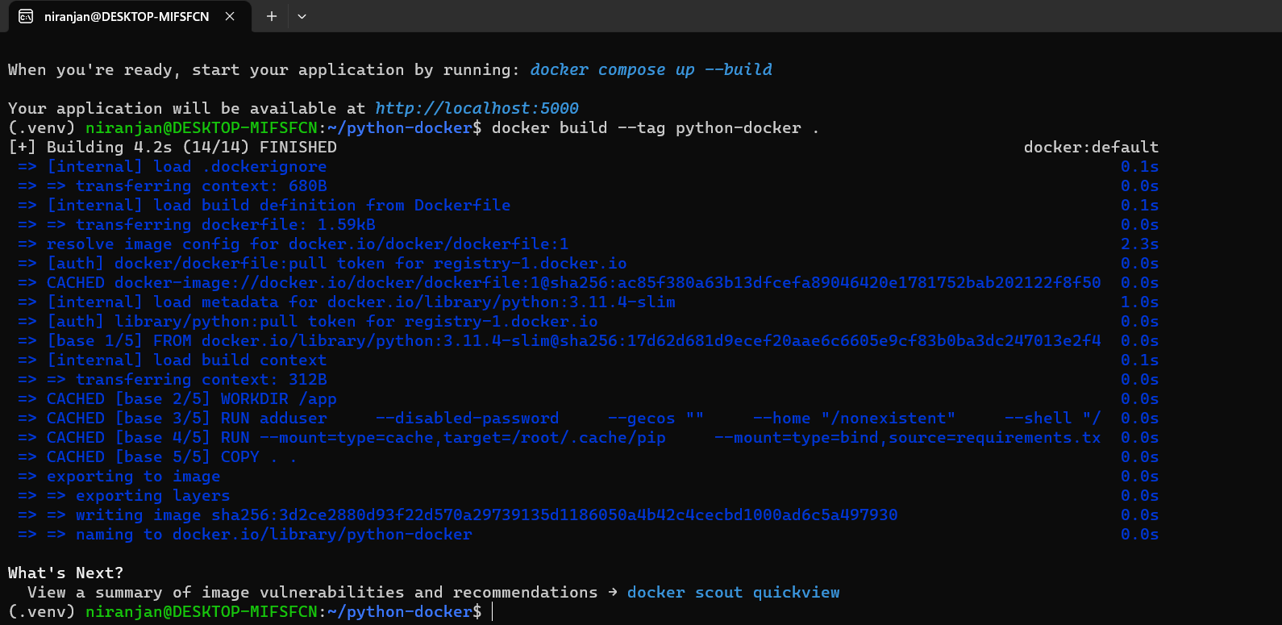

View local images, Tag images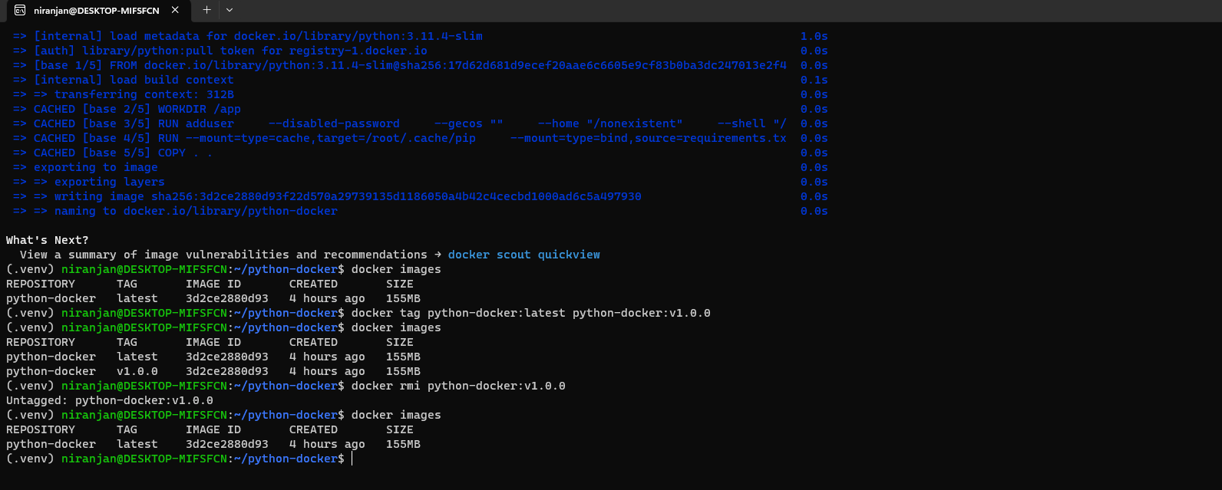

Run your image as a container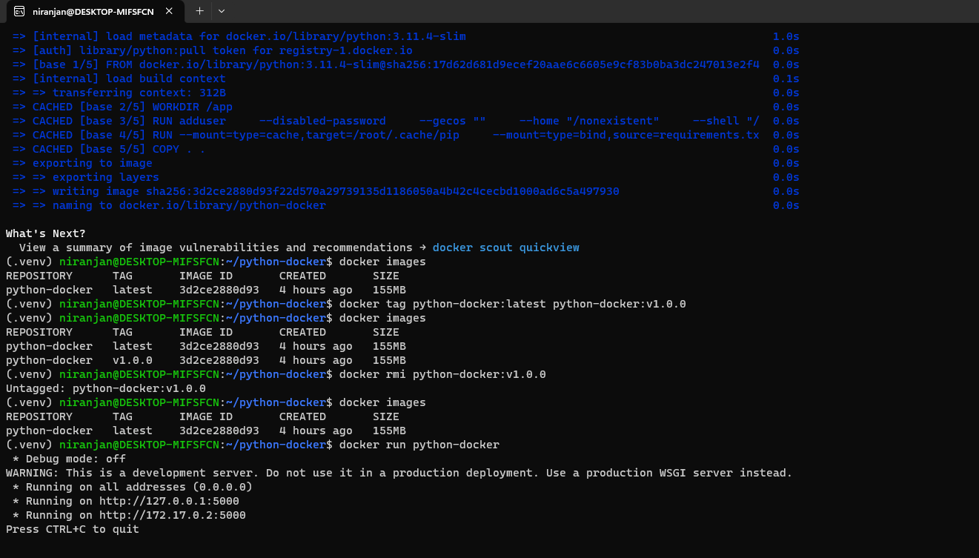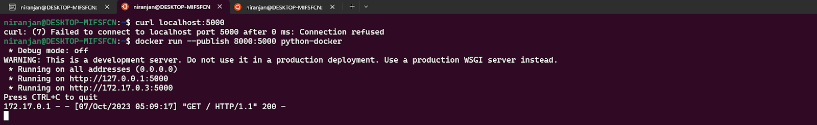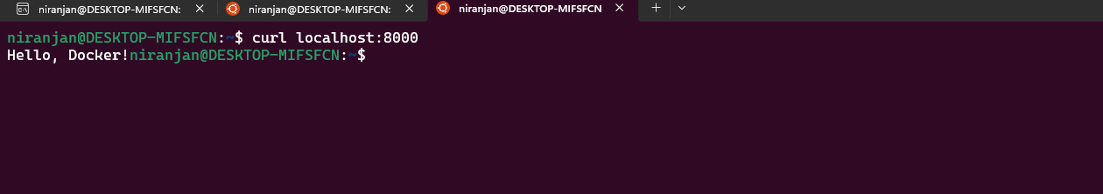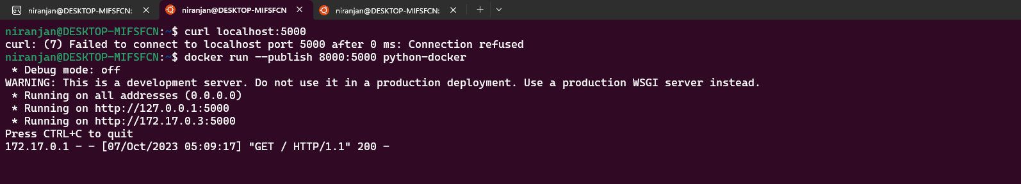

Run in detached mode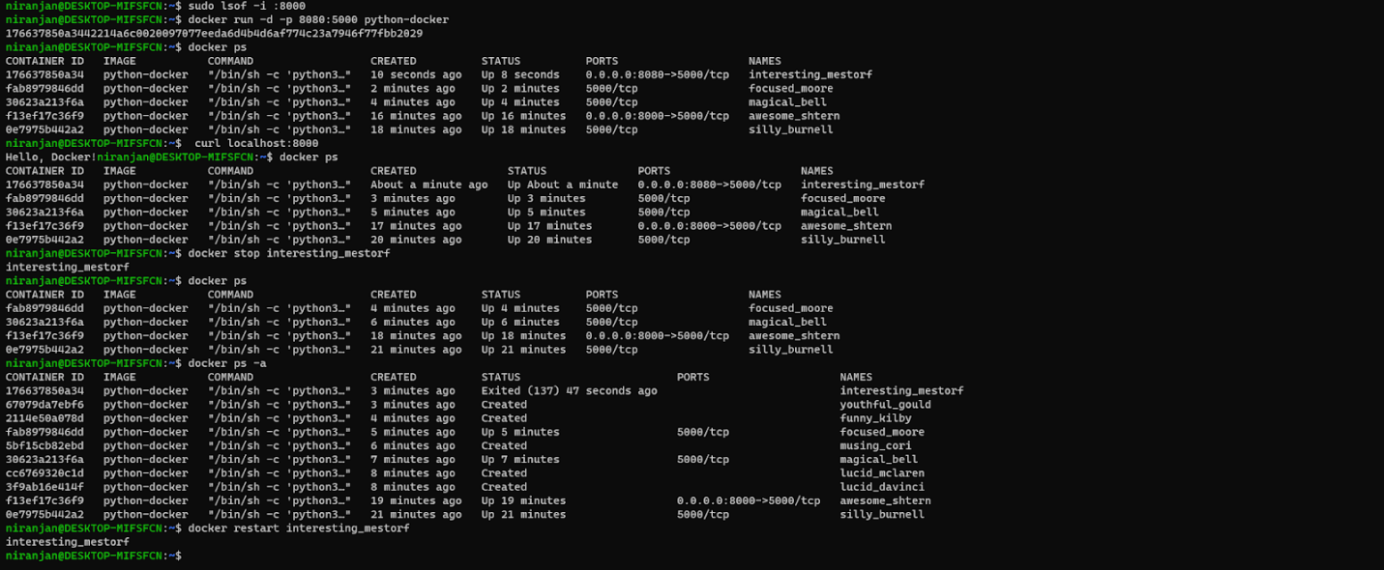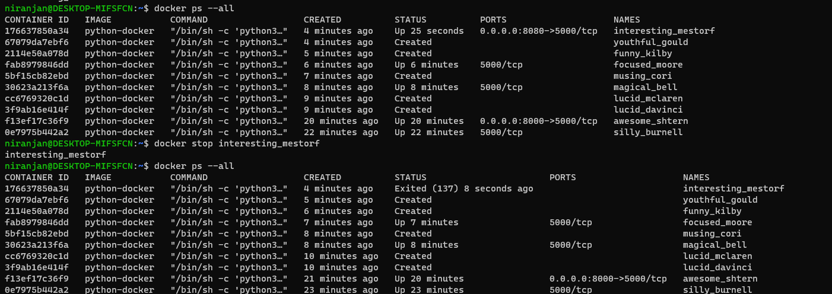

Run a database in a container

To create a volume

To create a Network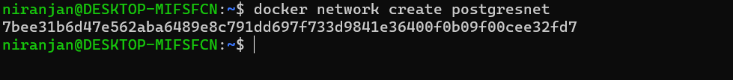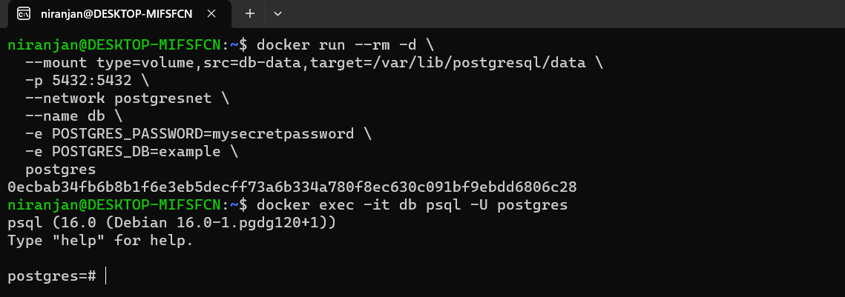

Change to a directory where you want to clone the repository and run the following command. 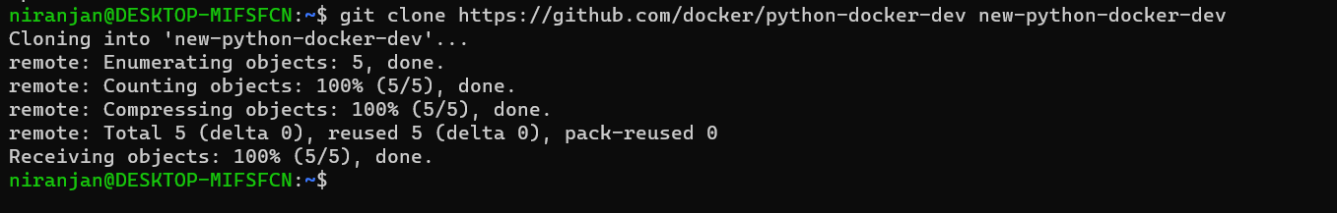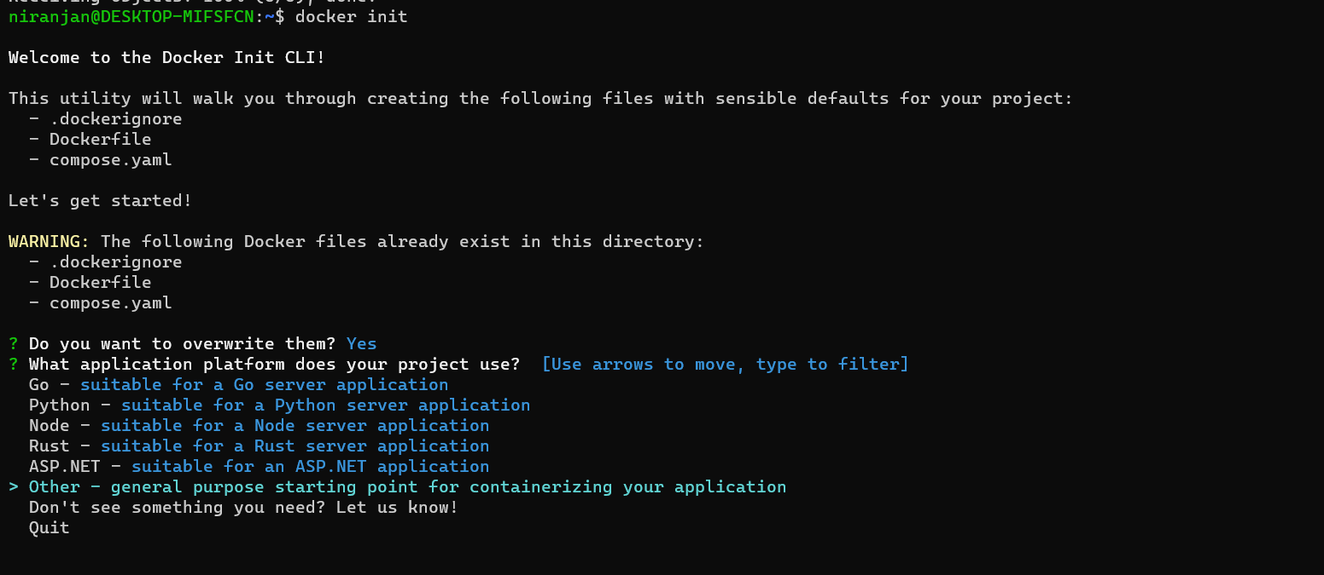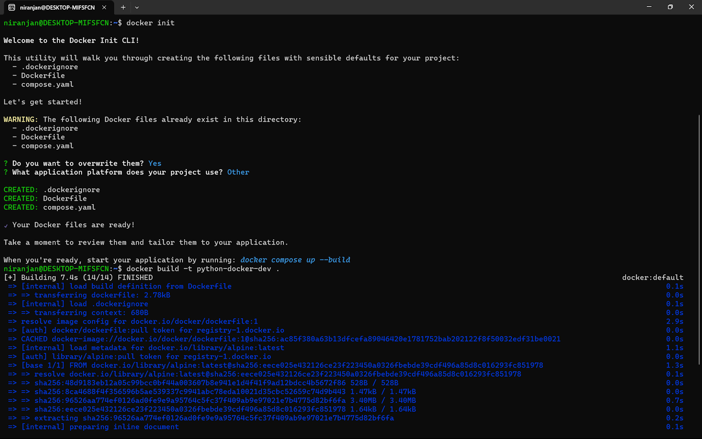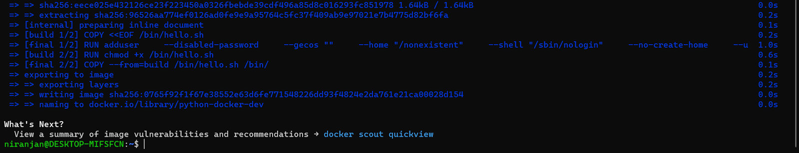

To Build the Image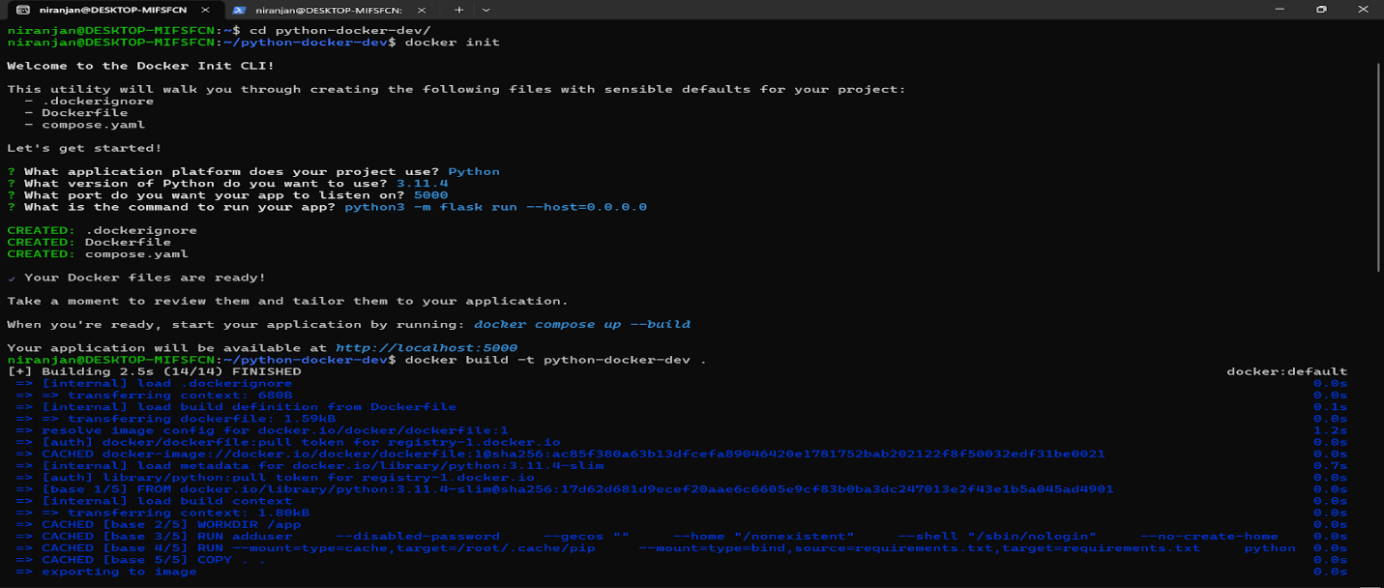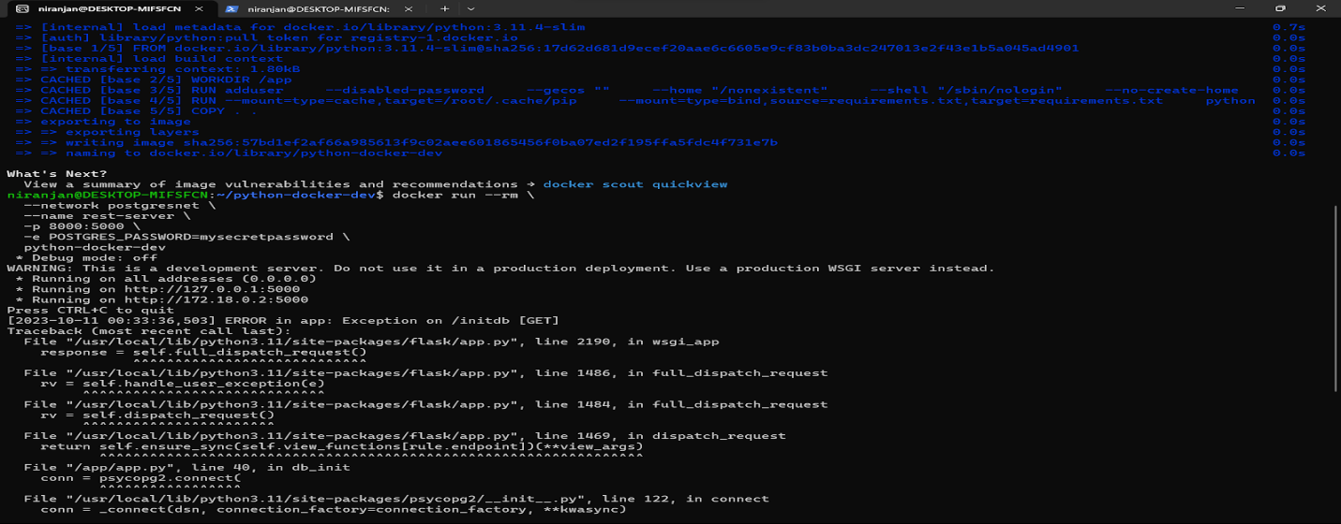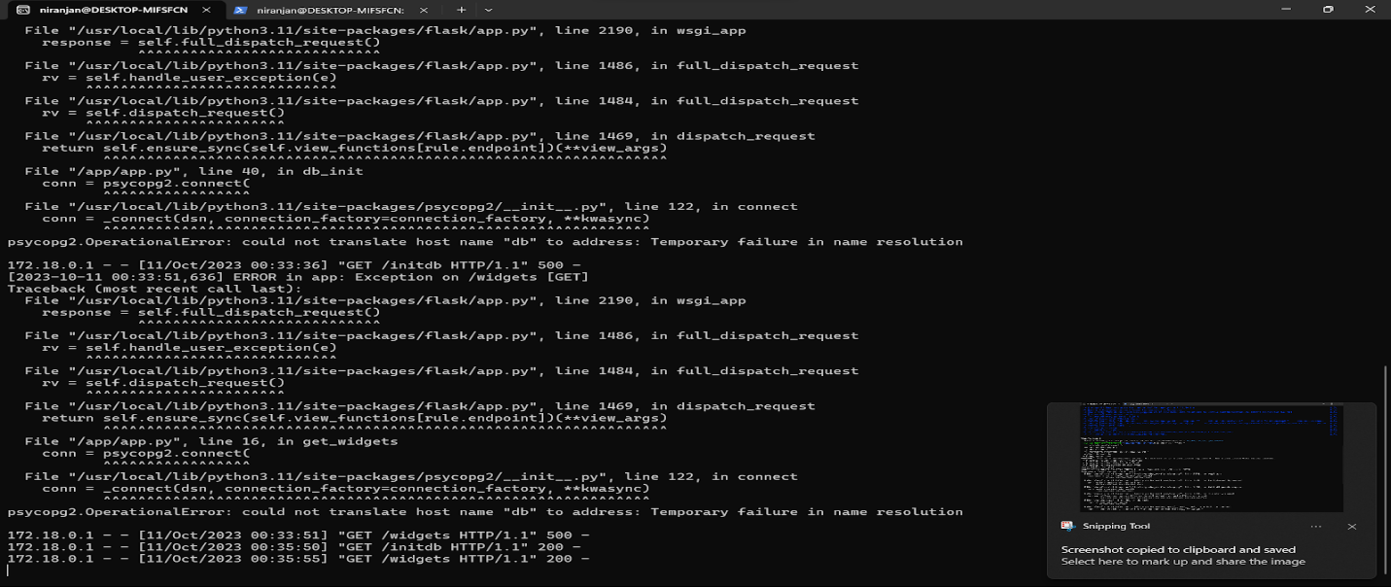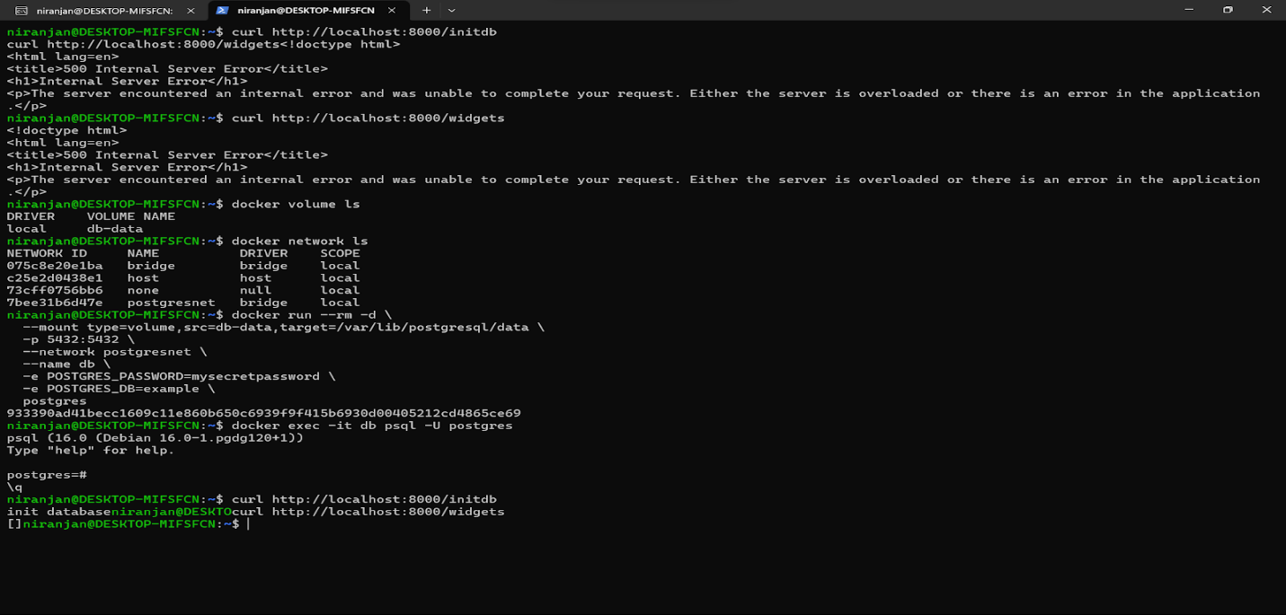

Use Compose to develop locally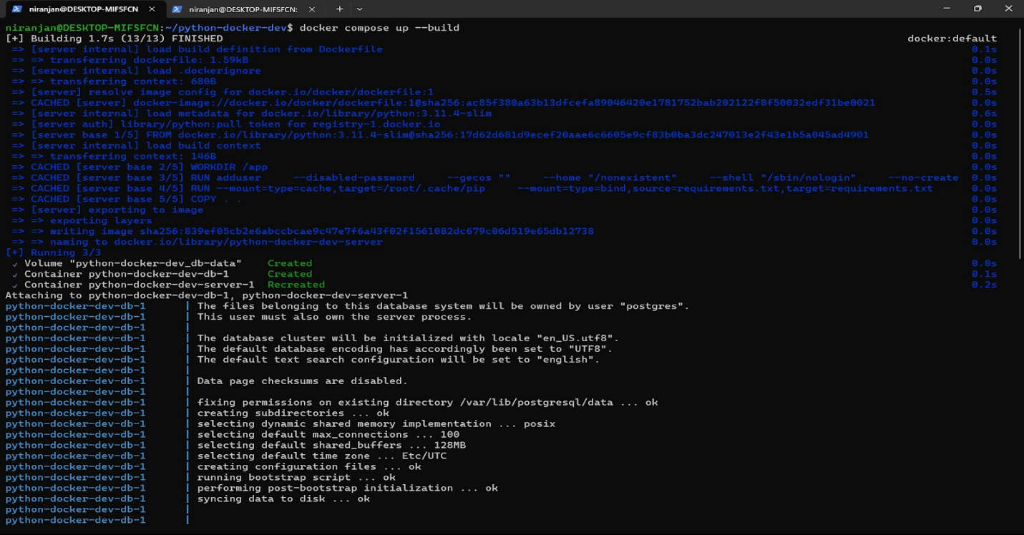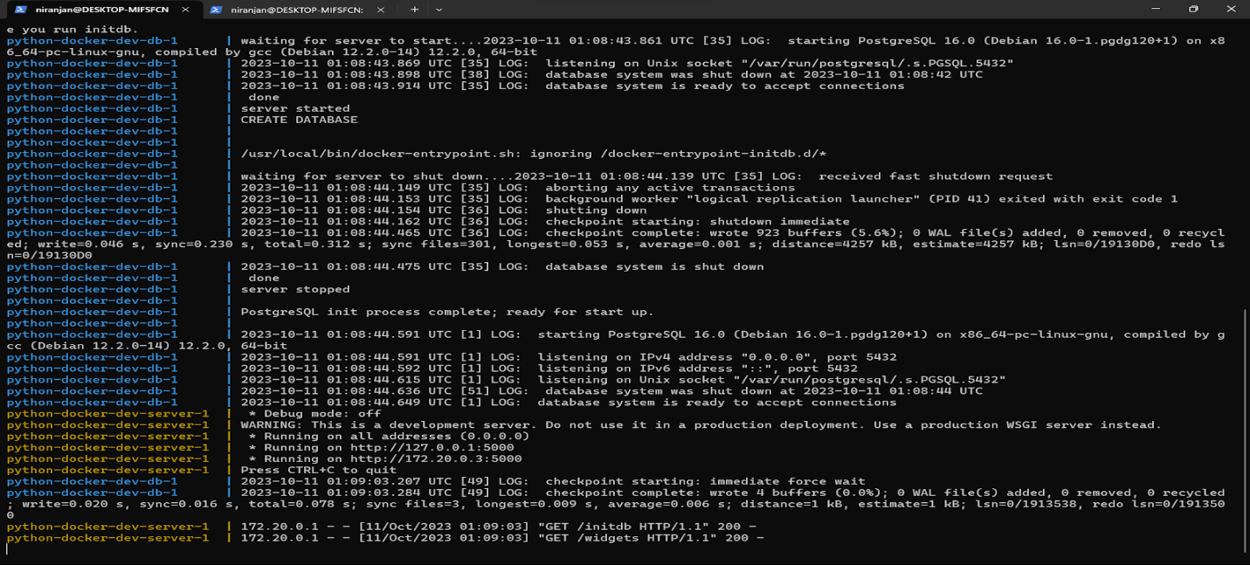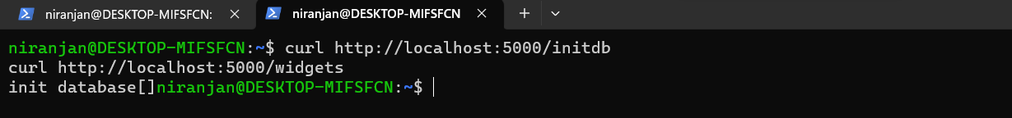

**Q2: Get started with gRPC**

Vinay- Java

Get Example Code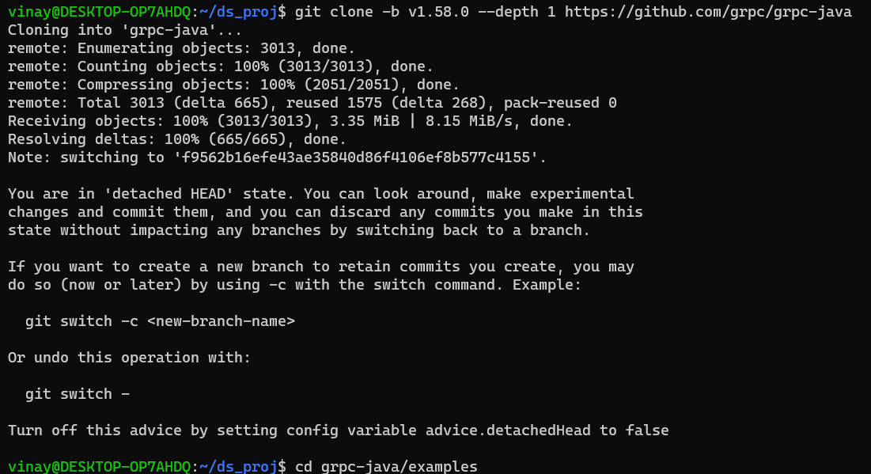

Run the example

Server side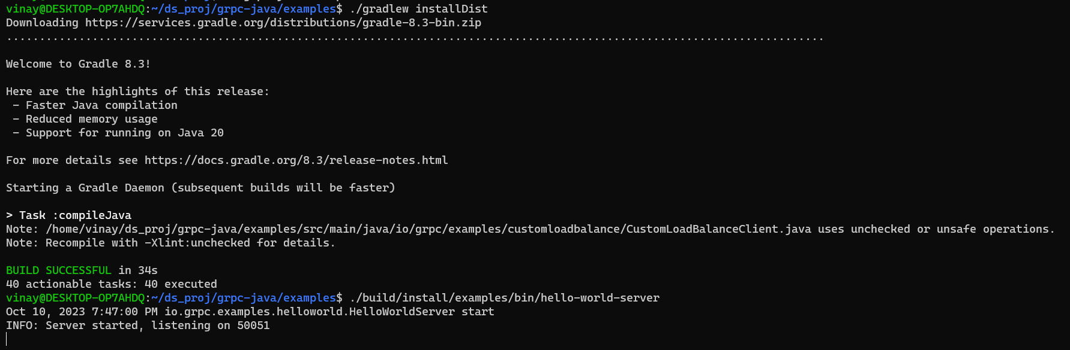

Client side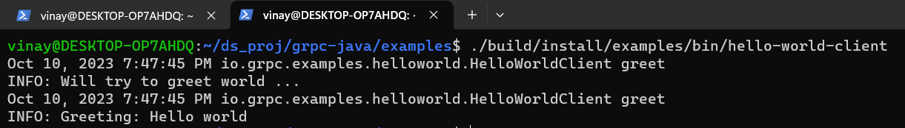

Update the grpc service

Update the App

Update the server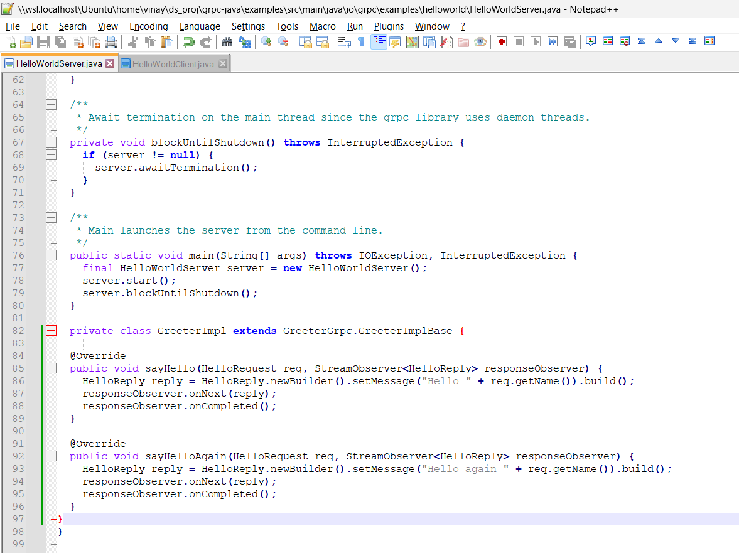

Update the client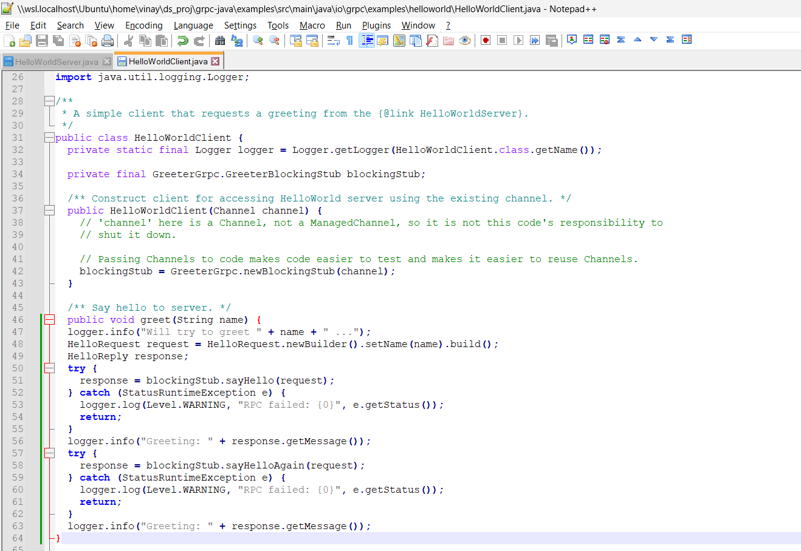

Run the updated app

Compile client and server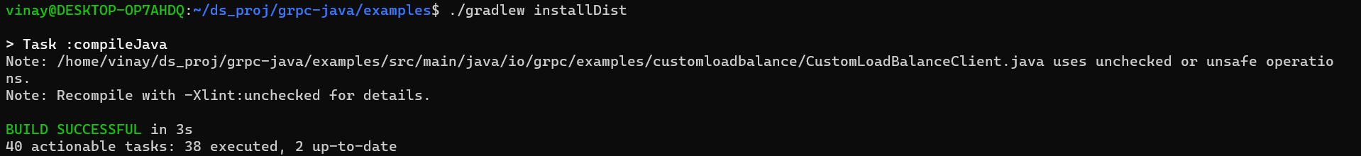

Run server

Run client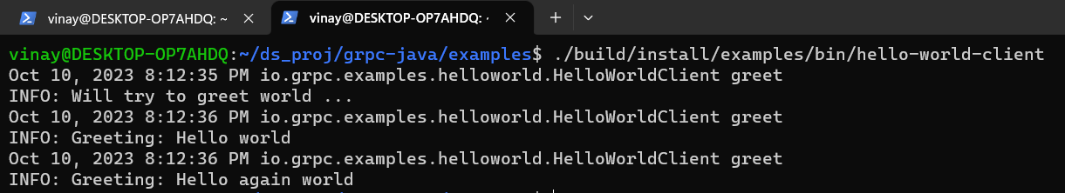

Niranjan- Python

GRPC

Install Grpc, Grpc tools 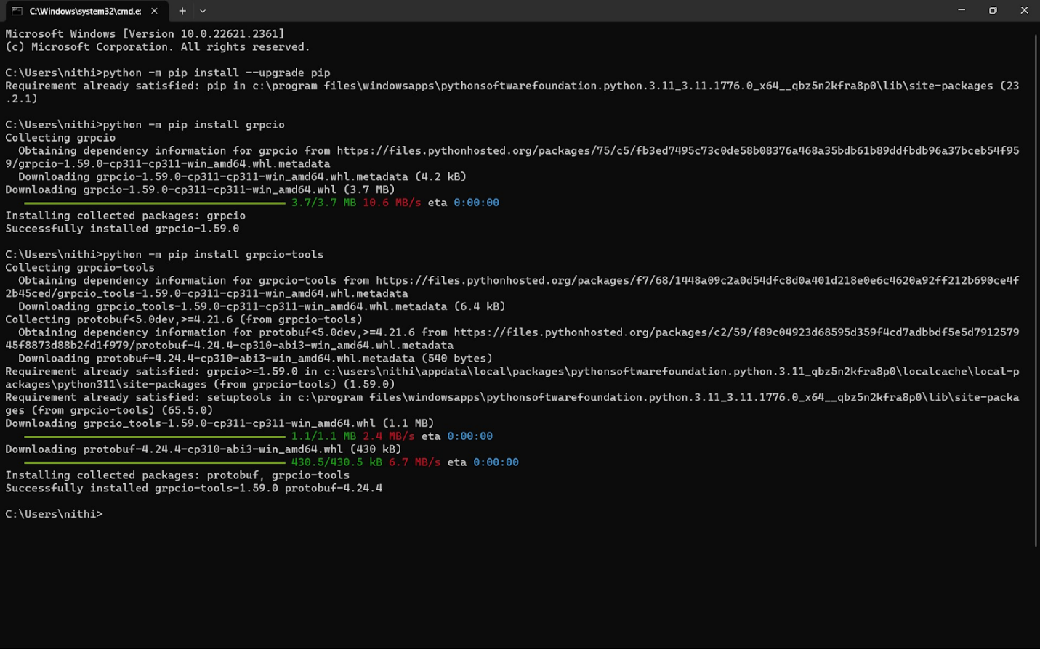

Get Example Code 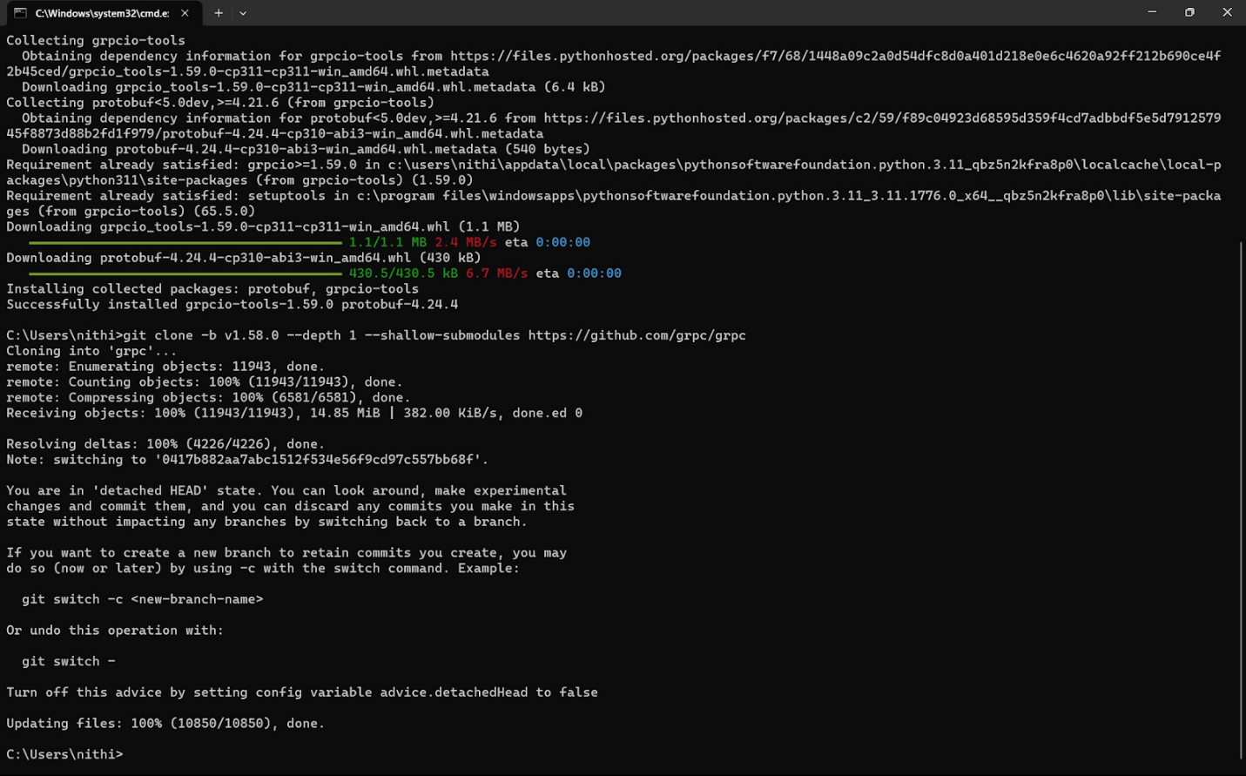

Run the GRPC 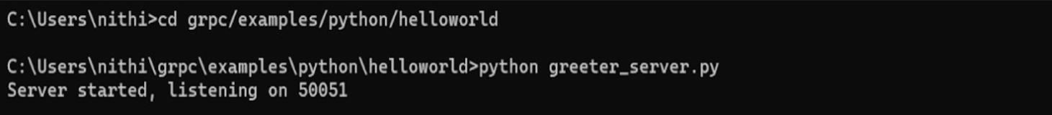 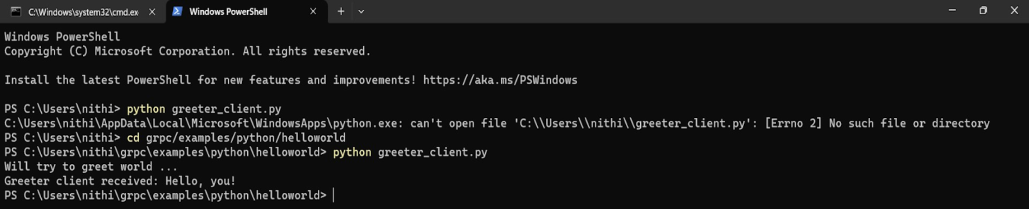

Update the Grpc service

Generate the Grpc Code 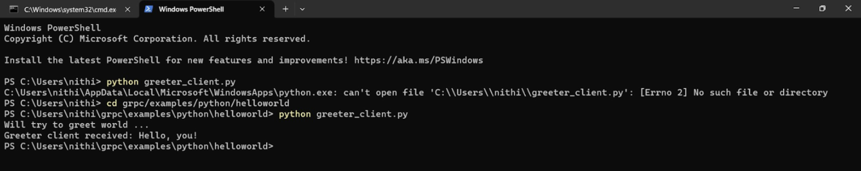

Updating and Running the Application

Update the Client & Server

Run the server.py 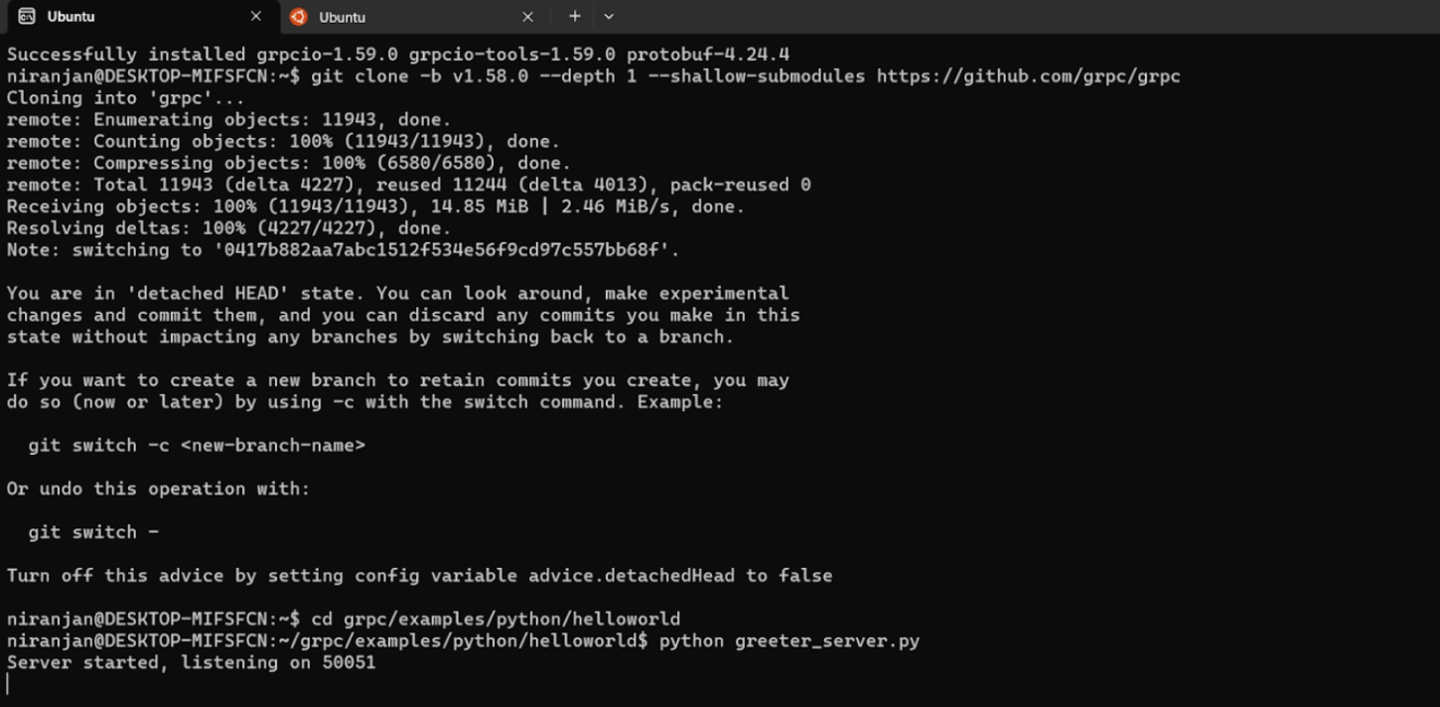

Run the client.py 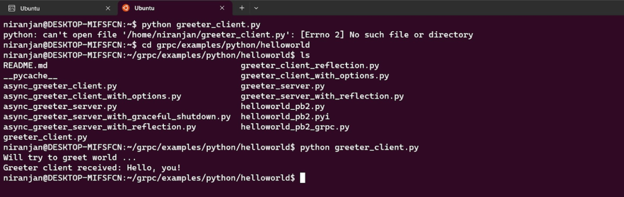

**Q3: Implementing a multi-threaded server for image search engine in a container**

Server side: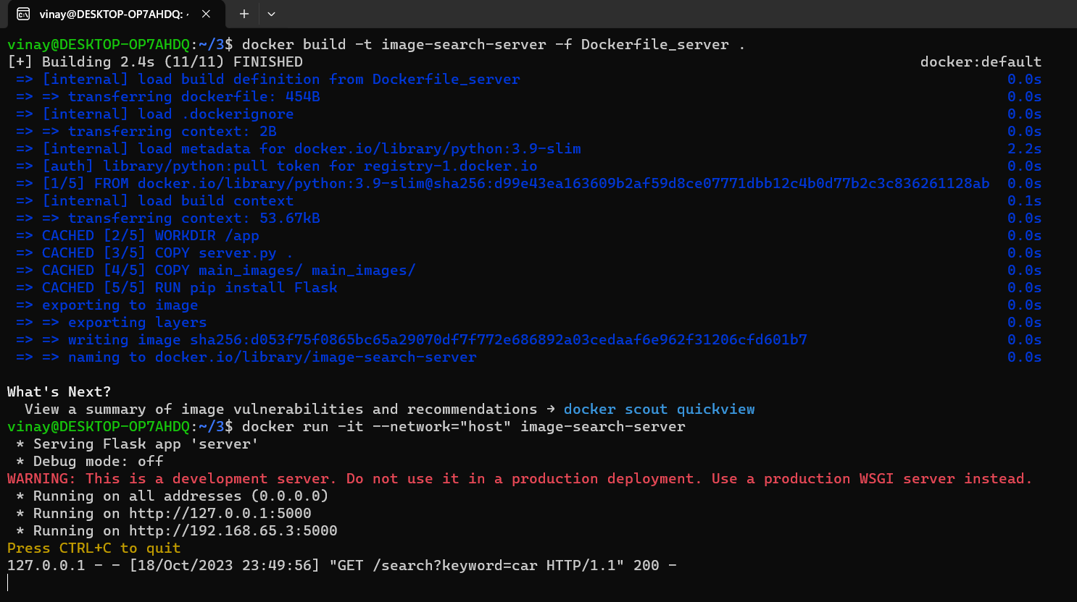

Client side: 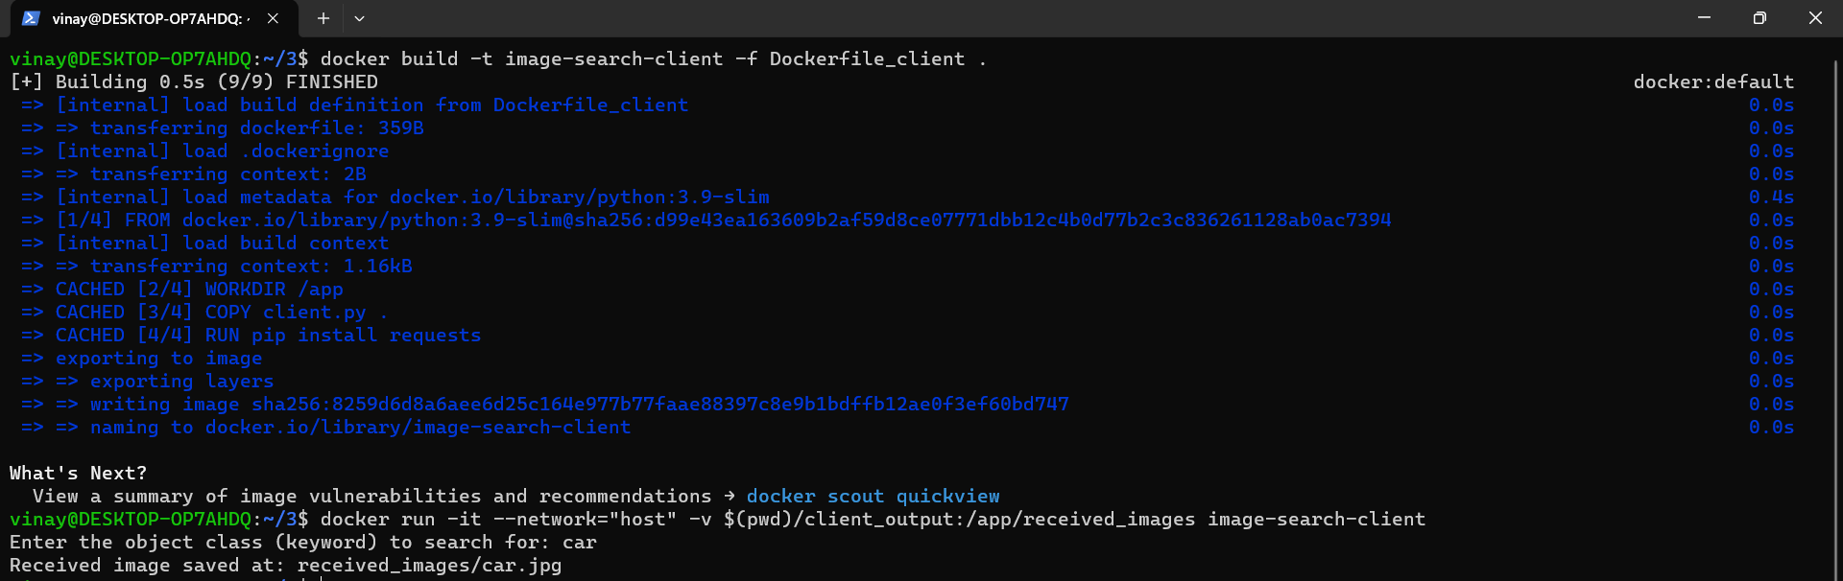

Output: 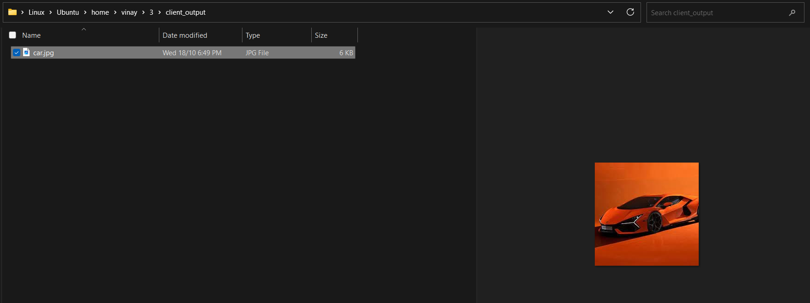

**Q4: Implement communication between server and client using gRPC**

Server side: 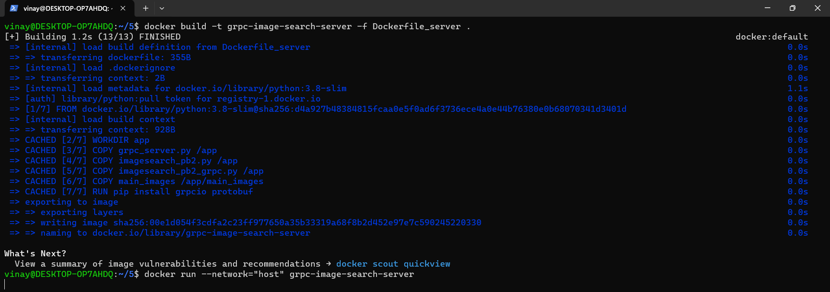

Client side: 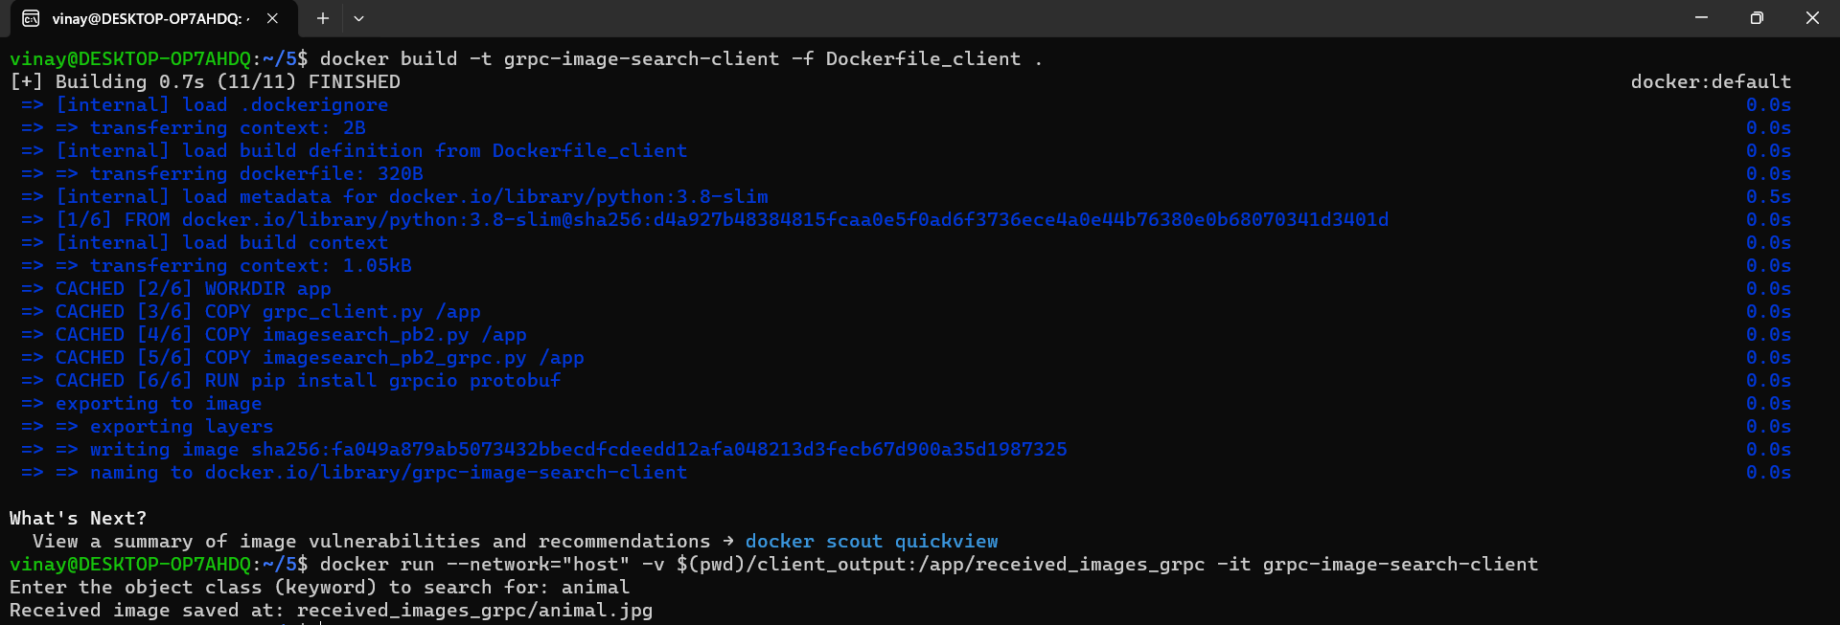

Output: 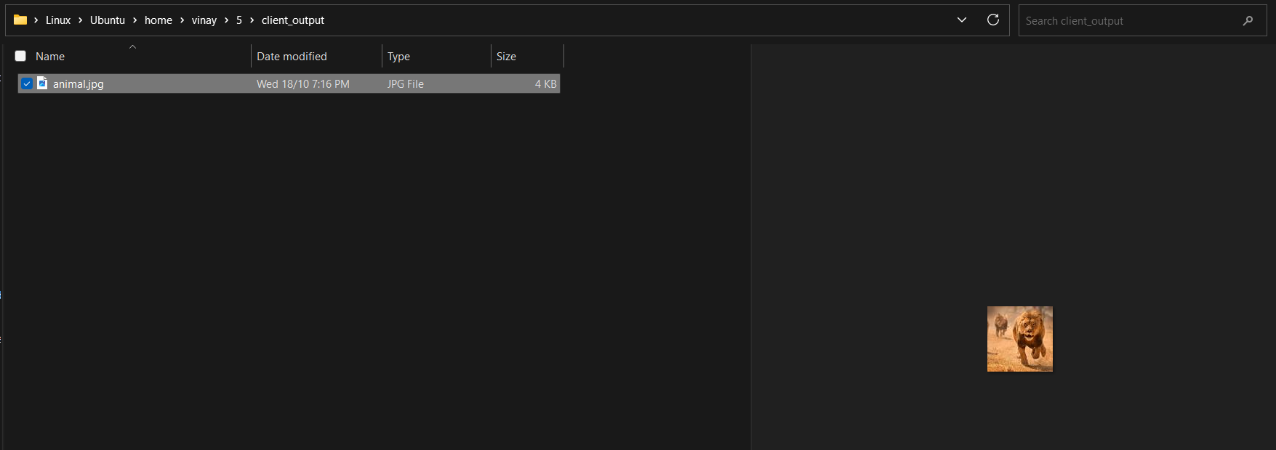

**Q5: Test cases**